**ls** : list files and directories gcc – help gcc number.c -o number -lm

**ls -a** :list all files and directories (including hidden files)

**ls –l** :list all files and detailed information

**rm filename** : remove a file

**rm –r directory** :remove a directory (This will delete all the files and directories under that directory. No way to recover!)

**rmdir directory** : remove an empty directory

**mv file1 file2** move (or rename) file1 to file2 If file2 exist, it will be overwritten by file1. mv test.c new.c move test.c to new.c under current directory mv test.c ../new.c move test.c to parent directory renamed as new.c

**mv file1 directory** move file1 to specified directory mv test.c ~/new move test.c to directory ~/new (if new exists)

**cp file1 file2** copy file1 to file2 cp test.c new.c copy test.c to new.c under current directory

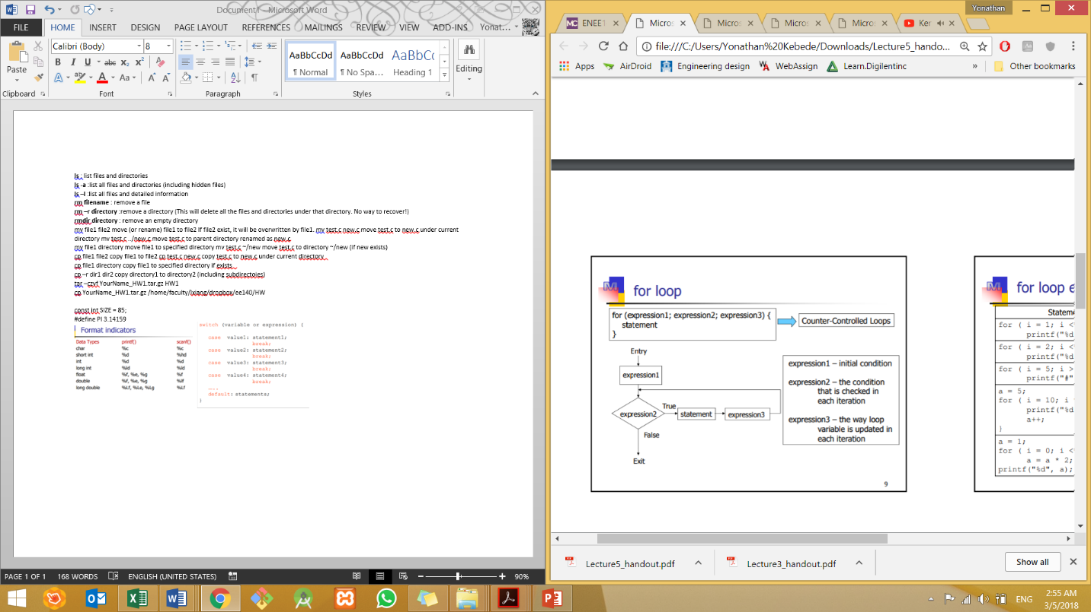**cp file1 directory** copy file1 to specified directory if exists

**cp –r dir1 dir2** copy directory1 to directory2 (including subdirectoies)

tar –czvf YourName_HW1.tar.gz HW1

cp YourName_HW1.tar.gz /home/faculty/lxiang/dropbox/ee140/HW

const int SIZE = 85;

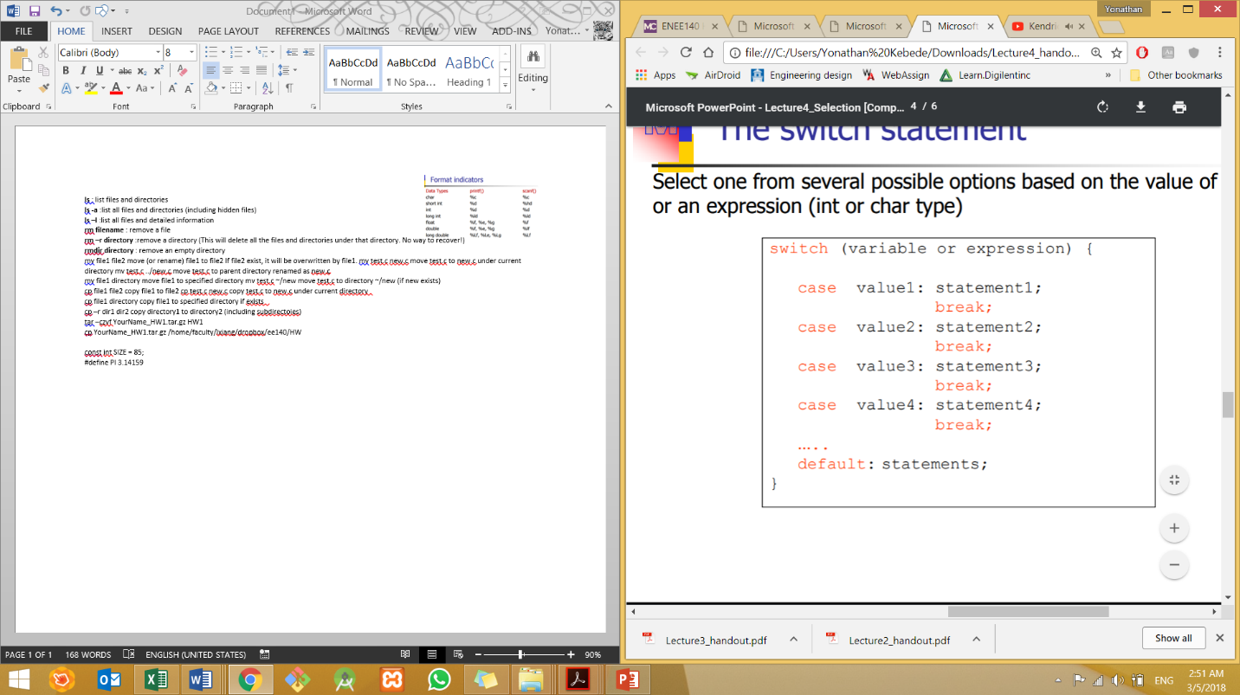#define PI 3.14159

